**PIZZA SALES SQL QUERIES**

**A.KPI’S**

**1.Total Revenue:**

SELECT SUM (total_price) AS Total_Revenue FROM pizzasales.pizza_sales

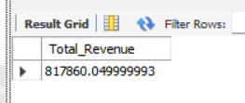

**2.Average_order_values:**

SELECT SUM(total_price)/COUNT (DISTINCT order_id) AS Average_order_value FROM pizzasales.pizza_sales;

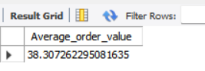

**3.Total_pizzas_sold:**

SELECT SUM(quantity) AS Total_pizzas_sold FROM pizzasales.pizza_sales;

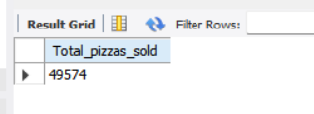

**4.Total_orders:**

SELECT COUNT(DISTINCT order_id) AS Total_orders FROM pizzasales.pizza_sales;

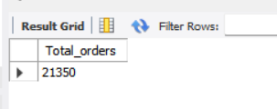

**5.Average_pizzas_per_order:**

SELECT SUM(quantity)/COUNT(DISTINCT order_id) AS Average_pizzas_per_order FROM pizzasales.pizza_sales;

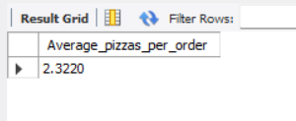

**CHART REQUIREMENTS**

**1.Daily_trend_for_total_orders:**

SHOW DATABASES; USE pizzasales; SHOW TABLES; DESCRIBE pizza_sales; SELECT DATE_FORMAT(order_date,'%W') AS order_day, COUNT(DISTINCT order_id) AS Daily_trend_for_total_orders FROM pizza_sales GROUP BY order_day;

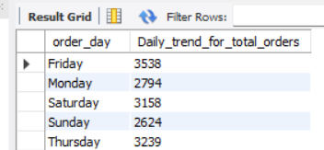



**2.Monthly_trend_for_total_orders:**

SELECT DATE_FORMAT(order_date,'%M') AS order_month,COUNT(DISTINCT order_id) AS Montly_trend_for_total_orders FROM pizza_sales GROUP BY order_month;

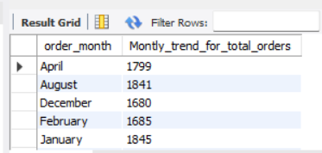

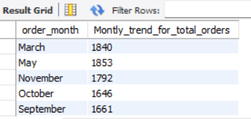



**3.Percentage_of_sales_by_pizza_category:**

SELECT pizza_category,SUM(total_price)/(SELECT SUM(total_price) FROM pizza_sales)*100 AS Percentage_of_sales_by_pizza_category FROM pizza_sales GROUP BY pizza_category;

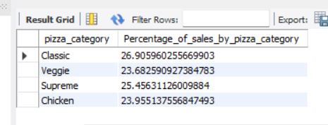

4. **Percentage_of_sales_by_pizza_size:**

SELECT pizza_size,SUM(total_price)/(SELECT SUM(total_price) FROM pizza_sales)*100 AS Percentage_of_sales_by_pizza_size FROM pizza_sales GROUP BY pizza_size;

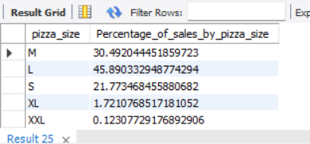

**5.Total_pizza_sold_by_pizza_category:**

SELECT pizza_category,SUM(quantity) AS Total_pizza_sold_by_pizza_category FROM pizza_sales GROUP BY pizza_category;

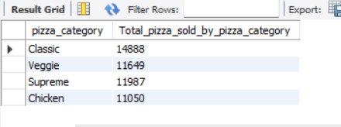

**6.Top 5 best sellers by revenue, total quantity and total orders:**

SELECT pizza_name,SUM(total_price) AS Total_revenue FROM pizza_sales

GROUP BY pizza_name

ORDER BY Total_revenue

DESC LIMIT 5;

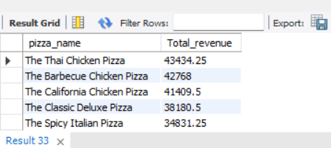

**7.Top 5 worst sellers by revenue, total quantity and total orders:**

SELECT pizza_name,SUM(total_price) AS Total_revenue FROM pizza_sales GROUP BY pizza_name ORDER BY Total_revenue ASC LIMIT 5;

